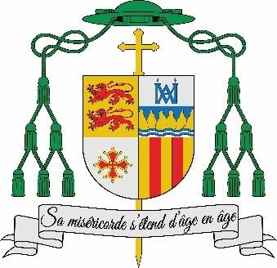**M****onsignor Jean-Marc MICAS**

BISHOP OF TARBES AND LOURDES

Tarbes, 21st November 2024

*Presentation of the Blessed Virgin Mary*

J U B I L E E 2 0 2 5

**Cathedral of Notre-Dame de la Sède**

**Sanctuary of Our Lady of Lourdes**

**Receiving the grace of Plenary Indulgence**

Dear brothers and sisters,

Pope Francis will open the Holy Door of St Peter's Basilica on 24th December, marking the beginning of the Ordinary Jubilee of 2025. The Jubilee will end on 6th January 2026, the Solemnity of the Epiphany of the Lord.

It is a great moment of grace for the whole Church, ‘a year of the Lord’s favour’ (cf. Isaiah 61:2)!

Pilgrims from all over the world will converge on Rome to pass through the Holy Door. It will also be possible to experience the grace of the Jubilee in the diocese (Cathedral of Notre-Dame de la Sède in Tarbes and the Sanctuary of Our Lady of Lourdes). The jubilee year will be officially opened in Lourdes during the mass on 31st December at the Grotto at 11pm, and at the cathedral on the feast of the Epiphany, 5thvv January at 5.30pm.

**The grace of a Plenary Indulgence:**

In the Bull of Indiction for the Ordinary Jubilee of the Year 2025, *Spes non confundit* (9th May 2024), Pope Francis emphasised that the Indulgence is the expression of God's mercy, which “becomes indulgence on the part of the Father who, through the Bride of Christ, his Church, reaches the pardoned sinner and frees him from every residue left by the consequences of sin.” He invites us to discover this gift of the Jubilee Indulgence: “The indulgence, in fact, allows us to discover the unlimited nature of God's mercy.”

# The conditions for receiving the grace of a plenary indulgence:

To obtain a plenary indulgence, the following conditions must be met:

* Carry out the works attached to the indulgence (going to the cathedral or the Sanctuary of Lourdes), and no more than seven days later:
  + Receive forgiveness through sacramental confession,
  + Receive Eucharistic Communion,
  + Pray for the Pope's intentions.

# Works to be performed to receive the grace of the Plenary Indulgence:

# In addition, the faithful may receive the indulgence by performing one of the following works:

* Participating in the Stations of the Cross,
* Praying the Rosary,
* Participating in a Marian Procession at the Sanctuary of Our Lady of Lourdes,
* Completing the Jubilee Way at the Sanctuary of Our Lady of Lourdes,
* Eucharistic Adoration,
* By receiving a solemn blessing from a bishop,
* By carrying out a work of mercy: ‘The faithful will be able to obtain the Jubilee indulgence if they visit, for an appropriate amount of time, their brothers and sisters who are in need or in difficulty (the sick, prisoners, lonely elderly people, disabled people...), in a sense making a pilgrimage to Christ present in them *(cf. Mt. 25:34-36)'. (Note from the Apostolic Penitentiary),*
* By practising the spirit of penance: ‘In particular, it means rediscovering the penitential nature of Fridays, by abstaining, at least for one day of the week, from futile distractions and superfluous consumption, as well as by donating a proportionate sum of money to the poor, by supporting works of a religious or social nature, especially in support of the defence and protection of life in all its phases, abandoned children, young people in difficulty, migrants from various countries, by dedicating a reasonable portion of one’s free time to voluntary activities that are of service to the community or to other similar forms of personal commitment.’ *(Note from the Apostolic Penitentiary).*

Since divine mercy will be offered on a large scale during the Jubilee Year, I ask that priests make themselves generously available to celebrate the sacrament of Penance.

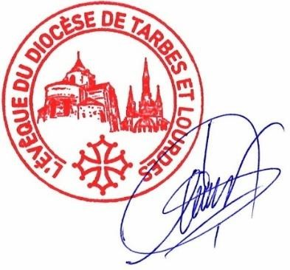I would like to wish you a wonderful Jubilee, placing, today, all your intentions in the hands of Our Lady of Lourdes!

+ Jean-Marc Micas